# What is Angular?

*"Angular is a platform that makes it easy to build applications with the web. Angular combines declarative templates, dependency injection, end to end tooling, and integrated best practices to solve development challenges. Angular empowers developers to build applications that live on the web, mobile, or the desktop".*

# Single Page Applications

Basically, when people talk about Angular, they talk about it as a JavaScript framework. It is used to build so-called Single Page Applications (SPA). These SPA's typically (but not only) use the browsers JavaScript environment to emulate the behavior of normal websites.

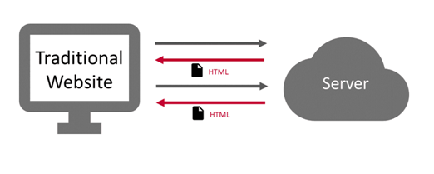

Because they don't rely on a server at all, they can do things, that we would expect from native applications. They have the ability to manage their state completely client-side, enabling a richer and much more fluent user experience.

Furthermore. server-round-trips can be avoided to a bare minimum, resulting in an overall more responsive application.

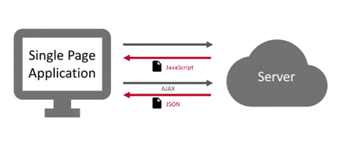

Thanks to technologies like [Service Workers](https://malcoded.com/posts/angular-service-worker) and [Progressive Web Apps](https://developers.google.com/web/progressive-web-apps/), these applications can become almost indistinguishable from native applications, especially on mobile (Android) devices.

# The Framework

The Angular framework enables us to write these single page applications with ease. It comes with features like data-binding, change-detection, forms, routing & navigation and an HTTP-implementation right out of the box.

Angular was originally intended to be used with the programming languages JavaScript, TypeScript and Dart. And although it is still possible to use it with all of these languages, the by far most popular language of choice became TypeScript.

I would highly recommend using TypeScript, as the other versions are not only lacking documentation and community, but updates are also released much later (months not days) than for the TypeScript version.

# The Platform

Over time, the angular developers have developed a great ecosystem around the framework.

Tools like the Angular-Cli, Angular Universal and Angular Material got added to the project. These tools added great features like fast project generation, server-side rendering, and stunning UI components, that are not coupled with the core-framework itself, but completely optional.

That is why angular is referred to as a platform. It provides all the tools, that you need, to develop great angular applications, without relying too much on third-party libraries. Because of this opinionated approach, most developers are using these tools, resulting in a great documentation, community help, and blog posts.



# Is it called AngularJS or Angular 5?

Maybe one of the greatest downsides of angular, to me, is the version and naming chaos that emerged after the Angular 2 release. Google decided to row back from the terms Angular 2, Angular 4, Angular 5, but to refer to them as just "Angular".

Don't get me wrong, having the universal "Angular" name for all version 2+ was the right decision, in my opinion. But this more general term makes searching (Google etc.) and finding the right information really hard.

Not only do people still get confused between AngularJS(v.1.x.x) and Angular (2+), but also use the "Angular 2", "Angular 4" and "Angular 5" terms in their posts and articles and especially headlines.

Furthermore, you also get AngularJS results, when searching for angular terms. At least this problem can be solved though...

# Removing AngularJS from your Search

You can easily exclude AngularJS search results form your search by using Google's search operators. By appending -angularjs to your search term, you only get true angular results. This can be a huge lifesaver!

# Just Call it Angular!

At this point, I would like to suggest, that you always refer to angular version 2 or higher as just angular. This greatly increases search-ability and communication in the angular community. Of course, you can and should clarify the version if you are using features that rely on a certain version.

# Angular Features

A list of most important features and benefits of Angular:

## Angular supports multiple platforms

Angular is a cross platform language. It supports multiple platforms. You can build different types of apps by using Angular.

1. **Desktop applications:** Angular facilitates you to create desktop installed apps on different types of operating systems i.e. Windows, Mac or Linux by using the same Angular methods which we use for creating web and native apps.
2. **Native applications:** You can built native apps by using Angular with strategies from Cordova, Ionic, or NativeScript.
3. **Progressive web applications:** Progressive web applications are the most common apps which are built with Angular. Angular provides modern web platform capabilities to deliver high performance, offline, and zero-step installation apps.

## High Speed, Ultimate Performance

Angular is amazingly fast and provides a great performance due to the following reasons:

1. **Universal support:** Angular can be used as a front-end web development tool for the programming languages like Node.js, .Net, PHP, Java Struts and Spring and other servers for near-instant rendering in just HTML and CSS. It also optimizes the website for better SEO.
2. **Code splitting:** Angular apps are fast and loads quickly with the new Component Router, which delivers automatic code-splitting so users only load code required to render the view they request.
3. **Code generation:** Angular makes your templates in highly optimized code for today?s JavaScript virtual machines which gives the benefits of hand-written code.

## Productivity

Angular provides a better productivity due to its simple and powerful template syntax, command line tools and popular editors and IDEs.

1. **Powerful templates:** Angular provides simple and powerful template syntax to create UI view quickly.
2. **IDEs:** Angular provides intelligent code completion, instant errors, and other feedback in popular editors and IDEs.
3. **Angular CLI:** Angular CLI provides command line tools start building fast, add components and tests, and then instantly deploy.

## Full Stack Development

Angular is a complete framework of JavaScript. It provides Testing, animation and Accessibility. It provides full stack development along with Node.js, Express.js, and MongoDB.

1. **Testing:** Angular provides Karma and Jasmine for unit testing. B y using it, you can check your broken things every time you save. Karma is a JavaScript test runner tool created by Angular team. Jasmine is the testing framework form unit testing in Angular apps, and Karma provides helpful tools that make it easier to us to call our Jasmine tests whilst we are writing code.
2. **Animation Support:** Angular facilitates you to create high-performance, complex choreographies and animation timelines with very little code through Angular's intuitive API.
3. **Accessibility:** In Angular, you can create accessible applications with ARIA-enabled components, developer guides, and built-in a11y test infrastructure.